ARTIFICIAL INTELLIGENCE – PROJECT 2
DATA CLASSIFICATION USING AI
Iris Flower Classification Using Decision Tree
Submitted By:
Name: SHAIK.SAMEED
Training/Internship: DecodeLabs
Batch: 2026
Project: Project 2
Technology: Python

1. INTRODUCTION
Artificial Intelligence is a field of computer science that focuses on creating systems capable of performing tasks that normally require human intelligence.
Machine Learning is an important part of Artificial Intelligence. It allows computers to learn patterns from data and make predictions or decisions without being explicitly programmed for every possible situation.
One important type of machine learning is supervised learning. In supervised learning, a model is trained using data that already contains the correct answers or labels.
This project demonstrates supervised learning through a classification problem. The model learns from measurements of iris flowers and predicts the category of a flower.
The project follows the basic machine-learning process:
Dataset → Data Preparation → Train/Test Split → Model Training → Prediction → Evaluation
This project corresponds to the DecodeLabs Project 2 requirement of building a basic classification model using a small dataset.

2. PROJECT OBJECTIVE
The main objective of this project is to develop a basic Artificial Intelligence classification model using Python.
The specific objectives are:
- To load and understand a dataset.
- To identify input features and target values.
- To divide the dataset into training and testing sets.
- To apply a simple classification algorithm.
- To train a machine-learning model.
- To make predictions using the trained model.
- To calculate the accuracy of the model.
- To generate visualizations for understanding the results.
- To test the model with a new flower sample.
These objectives directly address the project requirements of data handling, supervised learning basics, and model training.
3. PROBLEM STATEMENT
The problem addressed in this project is the automatic classification of iris flowers into different species based on their physical measurements.
The model receives four measurements:
- Sepal Length
- Sepal Width
- Petal Length
- Petal Width
Based on these measurements, the model predicts the flower species.
The three possible classes are:
- Setosa
- Versicolor
- Virginica
The goal is to train a machine-learning model that can correctly classify flowers based on the available features.

4. ARTIFICIAL INTELLIGENCE AND MACHINE LEARNING
Artificial Intelligence enables computers to perform tasks that involve learning, reasoning, decision-making, and pattern recognition.
Machine Learning is a subset of Artificial Intelligence in which computer systems learn patterns from data.
In traditional programming, a programmer provides rules and data to produce an output.
In machine learning:
Data + Correct Answers → Machine Learning Model → Learned Patterns
The trained model can then use the learned patterns to make predictions on new data.

5. CLASSIFICATION
Classification is a supervised machine-learning technique used to assign data to predefined categories or classes.
For example, an email classification system may classify emails as:
- Spam
- Not Spam
Similarly, this project classifies iris flowers into:
- Setosa
- Versicolor
- Virginica
The model learns from previously labeled examples and uses the learned patterns to classify new observations.

6. DATASET DESCRIPTION
The project uses the Iris flower dataset provided through Scikit-learn.
The dataset contains 150 samples and 4 input features.
The four features are:
Feature | Description
Sepal Length | Length of the flower's sepal
Sepal Width | Width of the flower's sepal
Petal Length | Length of the flower's petal
Petal Width | Width of the flower's petal
The target contains three flower classes:
Target | Flower
0 | Setosa
1 | Versicolor
2 | Virginica
The dataset is suitable for this project because it is small and contains labeled examples that can be used for supervised classification.

7. TECHNOLOGIES USED
The following technologies and libraries were used:
Python
Python is the main programming language used to implement the project.
Pandas
Pandas is used for handling and organizing the dataset in tabular form.
Matplotlib
Matplotlib is used to create graphs and visualizations.
Scikit-learn
Scikit-learn provides the machine-learning tools used in this project, including:
- Iris dataset
- Train/test splitting
- Decision Tree Classifier
- Accuracy calculation
- Confusion matrix
Visual Studio Code
Visual Studio Code is used as the development environment for writing and executing the Python program.

8. SYSTEM REQUIREMENTS
Hardware Requirements
- Computer or laptop
- Minimum 4 GB RAM
- Keyboard and mouse
- Sufficient storage space
Software Requirements
- Windows operating system
- Python 3.13
- Visual Studio Code
- Pandas
- NumPy
- Matplotlib
- Scikit-learn

9. METHODOLOGY
The project follows a sequence of steps to build and evaluate the classification model.
Step 1: Load the Dataset
The Iris dataset is loaded using Scikit-learn.
Step 2: Convert the Dataset
The data is converted into a Pandas DataFrame to make it easier to inspect and process.
Step 3: Understand the Dataset
The program displays:
- Dataset shape
- First five rows
- Dataset information
- Flower distribution
Step 4: Separate Features and Target
The input features are stored in X, while the target class is stored in y.
Step 5: Split the Dataset
The dataset is divided into:
- 80% training data
- 20% testing data
Step 6: Create the Model
A Decision Tree Classifier is created.
Step 7: Train the Model
The model learns patterns from the training data.
Step 8: Make Predictions
The trained model predicts the classes of the test data.
Step 9: Evaluate the Model
The predictions are compared with the actual classes and the accuracy is calculated.
Step 10: Visualize Results
The project generates:
- Confusion Matrix
- Decision Tree
- Feature graph
Step 11: Predict New Data
The trained model is used to predict the class of a new flower sample.

10. DATA PREPARATION
The dataset contains four input features and one target value.
The program separates them using:
X = data[iris.feature_names]
y = data["target"]
Here:
- X represents the input features.
- y represents the target class.
The model uses the values in X to learn how to predict y.

11. TRAINING AND TESTING
The dataset is divided into training and testing data using the train_test_split() function.
The project uses:
test_size=0.2
This means:
- 80% of the dataset is used for training.
- 20% of the dataset is used for testing.
The training data is used to teach the model.
The testing data is used to determine how well the trained model performs on data that was not used during training.
The project also uses:
random_state=42
This ensures that the same train/test split can be reproduced when the program is run again.

12. DECISION TREE ALGORITHM
A Decision Tree is a supervised machine-learning algorithm used for classification and prediction.
It works by dividing data based on feature values.
The structure of a Decision Tree consists of:
- Root node
- Decision nodes
- Branches
- Leaf nodes
The model makes decisions based on the features and eventually reaches a leaf node containing the predicted class.
In this project, the Decision Tree learns patterns from the measurements of iris flowers and uses those patterns to classify new flowers.
The model is created using:
model = DecisionTreeClassifier(random_state=42)
The model is trained using:
model.fit(X_train, y_train)

13. MODEL IMPLEMENTATION
The major implementation steps are shown below.
Importing Libraries
import pandas as pd
import matplotlib.pyplot as plt

from sklearn.datasets import load_iris
from sklearn.model_selection import train_test_split
from sklearn.tree import DecisionTreeClassifier, plot_tree
from sklearn.metrics import accuracy_score, confusion_matrix, ConfusionMatrixDisplay
These libraries provide the tools required for data handling, visualization, machine learning, and evaluation.
Loading the Dataset
iris = load_iris()
This loads the Iris dataset.
Creating the DataFrame
data = pd.DataFrame(
iris.data,
columns=iris.feature_names
)
This converts the feature data into a Pandas DataFrame.
Adding the Target
data["target"] = iris.target
The target class is added to the DataFrame.
Training the Model
model.fit(X_train, y_train)
This trains the Decision Tree using the training data.
Making Predictions
y_pred = model.predict(X_test)
This produces predictions for the testing data.
Calculating Accuracy
accuracy = accuracy_score(y_test, y_pred)
This calculates the percentage of correct predictions.

14. MODEL EVALUATION
Model evaluation is important because it tells us how well the trained model performs.
This project uses accuracy as one evaluation metric.
Accuracy can be represented as:
Accuracy = Correct Predictions / Total Predictions
The project calculates accuracy using:
accuracy_score(y_test, y_pred)
The obtained accuracy in this implementation was:
100%
This means that all observations in the test set were correctly classified in this particular train/test split.

15. RESULTS
The final model produced the following result:
Evaluation Metric | Result
Training Data | 80%
Testing Data | 20%
Classification Algorithm | Decision Tree
Model Accuracy | 100%
The model successfully trained and generated predictions for the testing data.
The project also successfully generated the following visualizations:
- Confusion Matrix
- Decision Tree Visualization
- Iris Feature Graph

16. CONFUSION MATRIX
A confusion matrix is used to understand the classification results.
It compares:
Actual Classes
with
Predicted Classes
The confusion matrix helps identify how many samples were correctly classified into each flower category.
Insert your image here:
Figure 1: Confusion Matrix
[INSERT confusion_matrix.png HERE]
Figure Description
The confusion matrix generated by the model shows the classification performance for the three Iris flower categories: Setosa, Versicolor, and Virginica.

17. DECISION TREE VISUALIZATION
The project also generates a visualization of the trained Decision Tree.
This visualization helps us understand how the model makes classification decisions based on the flower measurements.
Insert your image here:
Figure 2: Decision Tree Classification Model
[INSERT decision_tree.png HERE]
Figure Description
The Decision Tree visualization shows the different decision rules learned by the model during training.

18. IRIS FEATURE GRAPH
A feature graph is generated using petal length and petal width.
The graph helps visualize the relationship between these two features and the different flower classes.
Insert your image here:
Figure 3: Iris Flower Feature Classification
[INSERT iris_features.png HERE]
Figure Description
The feature graph represents the relationship between petal length and petal width for the Iris dataset.

19. NEW FLOWER PREDICTION
After training the model, the project tests it with a new flower sample.
The measurements used are:
Feature | Value
Sepal Length | 5.1 cm
Sepal Width | 3.5 cm
Petal Length | 1.4 cm
Petal Width | 0.2 cm
The program uses:
prediction = model.predict(new_flower)
The model then identifies the predicted flower class.
This demonstrates how a trained machine-learning model can be used to classify new data.
20. ADVANTAGES
The project has several advantages:
- It is simple and easy to understand.
- It demonstrates the basic supervised-learning workflow.
- The Iris dataset is small and easy to process.
- Decision Trees are relatively easy to interpret.
- The model can classify new flower samples.
- The project provides visual results.
- Python and Scikit-learn make implementation easier.
- The project provides practical experience with machine learning.

21. LIMITATIONS
Although the project successfully demonstrates classification, it has some limitations.
- The project uses a relatively small dataset.
- Only one classification algorithm is used.
- The model is evaluated primarily using accuracy.
- The project does not use a large real-world dataset.
- The model may perform differently on other datasets.
- A 100% accuracy result on one test split does not necessarily mean the model will achieve 100% accuracy on every unseen dataset.

22. FUTURE SCOPE
The project can be improved in several ways.
Use More Classification Algorithms
Different algorithms could be compared, such as:
- Logistic Regression
- K-Nearest Neighbors
- Support Vector Machine
- Random Forest
Use Additional Evaluation Metrics
Future versions could include:
- Precision
- Recall
- F1-score
- Cross-validation
Use Larger Datasets
The project could be extended to larger and more realistic datasets.
Create a User Interface
A simple graphical or web interface could allow users to enter flower measurements and receive predictions.
Deploy the Model
The trained model could be integrated into a web application or other software system.
The DecodeLabs project guidance also encourages experimenting with different algorithms and testing models with new data as part of learning.

23. CONCLUSION
This project successfully demonstrates the basic process of Data Classification Using Artificial Intelligence.
The Iris dataset was loaded and analyzed using Python and Pandas. The data was divided into training and testing sets, with 80% used for training and 20% used for testing.
A Decision Tree Classifier was trained using the training data. The trained model was then used to make predictions on the testing data.
The model achieved an accuracy of 100% on the selected test set. A confusion matrix, Decision Tree visualization, and feature graph were also generated to understand the model's performance and decision-making process.
The project provided practical knowledge of:
- Data handling
- Supervised learning
- Classification
- Train/test splitting
- Model training
- Prediction
- Accuracy evaluation
- Data visualization
Overall, this project provided a practical introduction to machine-learning classification and established a foundation for more advanced Artificial Intelligence projects.

24. REFERENCES
- DecodeLabs Artificial Intelligence – Project 2: Data Classification Using AI.
- DecodeLabs Project 2 requirements and learning objectives.
- Scikit-learn documentation and Python machine-learning libraries used in the implementation.
- Python programming language and standard library documentation.

Appendix A – Source Code
APPENDIX A – SOURCE CODE
The following Python program was developed for Project 2: Data Classification Using AI. It loads the Iris dataset, prepares the data, divides it into training and testing sets, trains a Decision Tree classification model, evaluates its accuracy, displays the confusion matrix and visualizations, and predicts the class of a new flower.
# ==========================================================
# PROJECT 2: DATA CLASSIFICATION USING AI
# Iris Flower Classification using Decision Tree
# ==========================================================
import pandas as pd
import matplotlib.pyplot as plt

from sklearn.datasets import load_iris
from sklearn.model_selection import train_test_split
from sklearn.tree import DecisionTreeClassifier, plot_tree
from sklearn.metrics import accuracy_score, confusion_matrix, ConfusionMatrixDisplay

# ----------------------------------------------------------
# 1. LOAD DATASET
# ----------------------------------------------------------
iris = load_iris()

data = pd.DataFrame(
iris.data,
columns=iris.feature_names
)
data["target"] = iris.target
# Add flower names
data["flower_name"] = data["target"].map(
{
0: "Setosa",
1: "Versicolor",
2: "Virginica"
}
)

# ----------------------------------------------------------
# 2. UNDERSTAND THE DATASET
# ----------------------------------------------------------

print("=" * 50)
print("IRIS FLOWER CLASSIFICATION")
print("=" * 50)
print("\nDataset shape:")
print(data.shape)
print("\nFirst 5 rows:")
print(data.head())
print("\nDataset information:")
print(data.info())
print("\nFlower distribution:")
print(data["flower_name"].value_counts())
# ----------------------------------------------------------
# 3. SEPARATE FEATURES AND TARGET
# ----------------------------------------------------------
X = data[iris.feature_names]
y = data["target"]
# ----------------------------------------------------------
# 4. SPLIT DATA INTO TRAINING AND TESTING
# ----------------------------------------------------------
X_train, X_test, y_train, y_test = train_test_split(
X,
y,
test_size=0.2,
random_state=42
)

print("\nTraining samples:", len(X_train))
print("Testing samples:", len(X_test))
# ----------------------------------------------------------
# 5. CREATE CLASSIFICATION MODEL
# ----------------------------------------------------------
model = DecisionTreeClassifier(
random_state=42
)
# ----------------------------------------------------------
# 6. TRAIN THE MODEL
# ----------------------------------------------------------
model.fit(X_train, y_train)
print("\nModel training completed successfully.")
# ----------------------------------------------------------
# 7. MAKE PREDICTIONS
# ----------------------------------------------------------
y_pred = model.predict(X_test)
# ----------------------------------------------------------
# 8. CALCULATE ACCURACY
# ----------------------------------------------------------
accuracy = accuracy_score(y_test, y_pred)
print("\nModel Accuracy:", accuracy)
print("Model Accuracy (%):", accuracy * 100)
# ----------------------------------------------------------
# 9. CONFUSION MATRIX
# ----------------------------------------------------------

cm = confusion_matrix(y_test, y_pred)
print("\nConfusion Matrix:")
print(cm)
disp = ConfusionMatrixDisplay(
confusion_matrix=cm,
display_labels=iris.target_names
)
disp.plot()
plt.title("Confusion Matrix")
plt.tight_layout()
plt.savefig("confusion_matrix.png", dpi=300)
plt.show()
# ----------------------------------------------------------
# 10. DECISION TREE VISUALIZATION
# ----------------------------------------------------------
plt.figure(figsize=(15, 10))
plot_tree(
model,
feature_names=iris.feature_names,
class_names=iris.target_names,
filled=True
)
plt.title("Decision Tree Classification Model")
plt.tight_layout()
plt.savefig("decision_tree.png", dpi=300)
plt.show()
# ----------------------------------------------------------
# 11. FEATURE GRAPH
# ----------------------------------------------------------
plt.figure(figsize=(8, 6))
plt.scatter(
data["petal length (cm)"],
data["petal width (cm)"],
c=data["target"]
)
plt.xlabel("Petal Length (cm)")
plt.ylabel("Petal Width (cm)")
plt.title("Iris Flower Classification")
plt.tight_layout()
plt.savefig("iris_features.png", dpi=300)
plt.show()

# ----------------------------------------------------------
# 12. PREDICT A NEW FLOWER
# ----------------------------------------------------------
new_flower = [[
5.1, # Sepal length
3.5, # Sepal width
1.4, # Petal length
0.2 # Petal width
]]
prediction = model.predict(new_flower)
predicted_flower = iris.target_names[prediction[0]]
print("\nNew Flower Prediction:")
print("Predicted Flower:", predicted_flower)
# ----------------------------------------------------------
# 13. FINAL RESULT
# ----------------------------------------------------------
print("\n" + "=" * 50)
print("PROJECT COMPLETED SUCCESSFULLY")
print("=" * 50)

APPENDIX B – PROJECT OUTPUT
The following outputs were generated after executing the Python program successfully.
B.1 Program Execution Output
The program successfully loaded the Iris dataset, trained the Decision Tree classification model, tested the model, and generated predictions.
Model Accuracy: 100%
New Flower Prediction: Setosa
B.2 Confusion Matrix
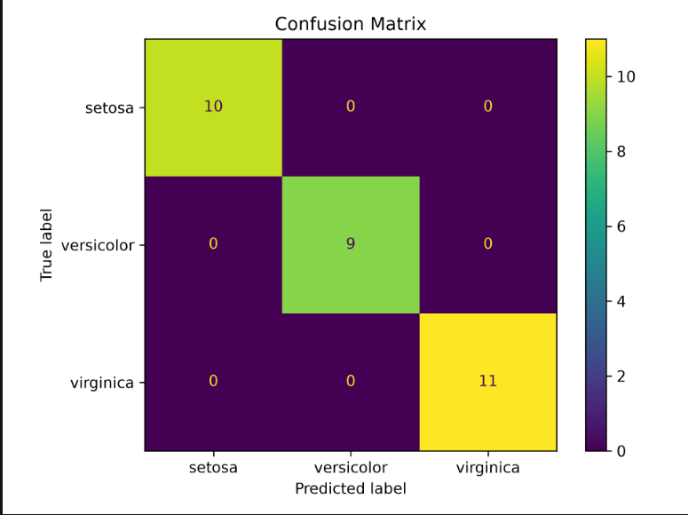
Figure B.1: Confusion Matrix of the Decision Tree Classification Model
B.3 Decision Tree Visualization
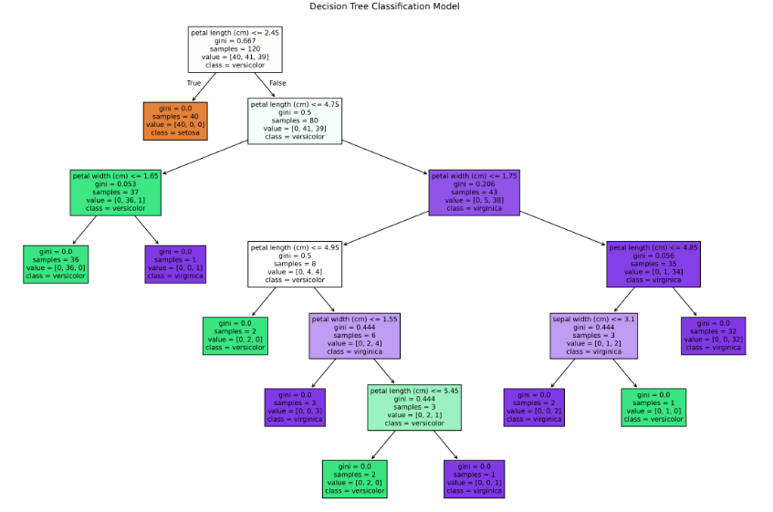
Figure B.2: Decision Tree Classification Model
B.4 Iris Feature Graph
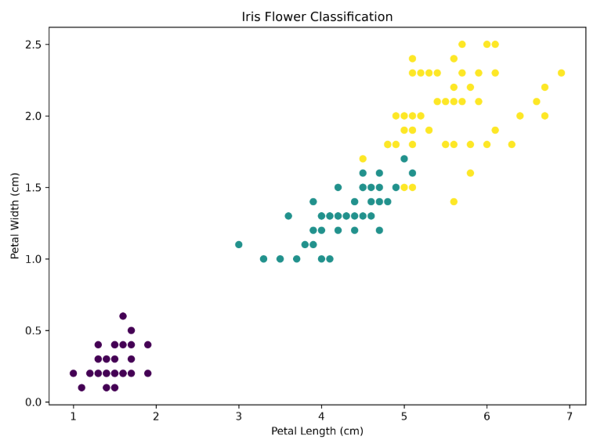Figure B.3: Iris Flower Feature Classification Graph

